**2 garment pockets golf cart bag**

TH-Sport Golf Product

* 2 garment pockets golf cart bag
* Item:1015
* Material:High quality PU
* 7- way 9.5 "oval top
* Easy access porkets for storage
* Waterproof
* Cart sleeve prevents bag from twisting on cart
* Convenient putter clip
* Rainhood included
* High quality with fashion design
* Customers' brand are welcomed
* 3 months quality guaranteed

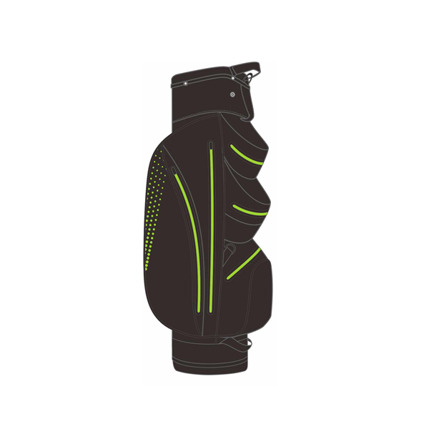

More information please click:www.tt-sport.com